Date- 14/10/2023

Roll No. - 13

Expt. No. - 8

K.M.S.P. Mandal’s

Sant Rawool Maharaj Mavidyalaya, Kudal

**Department of Computer Science**

Signature

Perform a forensic analysis of a mobile device, such as a smartphone or tablet & Retrieve call logs, text messages, and other relevant data for investigative purposes.

Title - _______________________________________________________

_______________________________________________________

MOBILedit Forensic is a mobile phone forensic software developed by Compelson Labs. It's designed for digital forensic investigators, law enforcement agencies, and other professionals who need to extract, analyze, and report on data from mobile devices. The software supports a wide range of mobile platforms, including Android, iOS, and others.

**Key features of MOBILedit Forensic include:**

**1. Data Extraction:** The software allows forensic experts to extract various types of data from mobile devices, including call logs, messages, contacts, multimedia files, application data, and more.

**2. Phonebook and Contact Analysis:**Investigators can analyze and retrieve information from the phonebook and contact lists, helping to establish connections between individuals.

**3. Message Analysis:** MOBILedit Forensic can recover and analyze SMS messages, MMS messages, and other messaging app data.

**4. File System Extraction:** It enables the extraction of data from the file system of mobile devices, providing access to deleted files, metadata, and other information.

**5. App Data Analysis:** The software supports the extraction and analysis of data from various mobile applications, helping investigators understand user activities within apps.

**6. Physical and Logical Extraction:** MOBILedit Forensic supports both physical and logical extraction methods, allowing investigators to choose the most suitable approach based on the device and case requirements.

**7. SIM Card Analysis:** It includes tools for analyzing data stored on SIM cards, such as contacts, call logs, and SMS messages.

**8. Reporting:** The software offers reporting features to document and present findings in a clear and organized manner for legal and investigative purposes.

**MOBILedit interface**

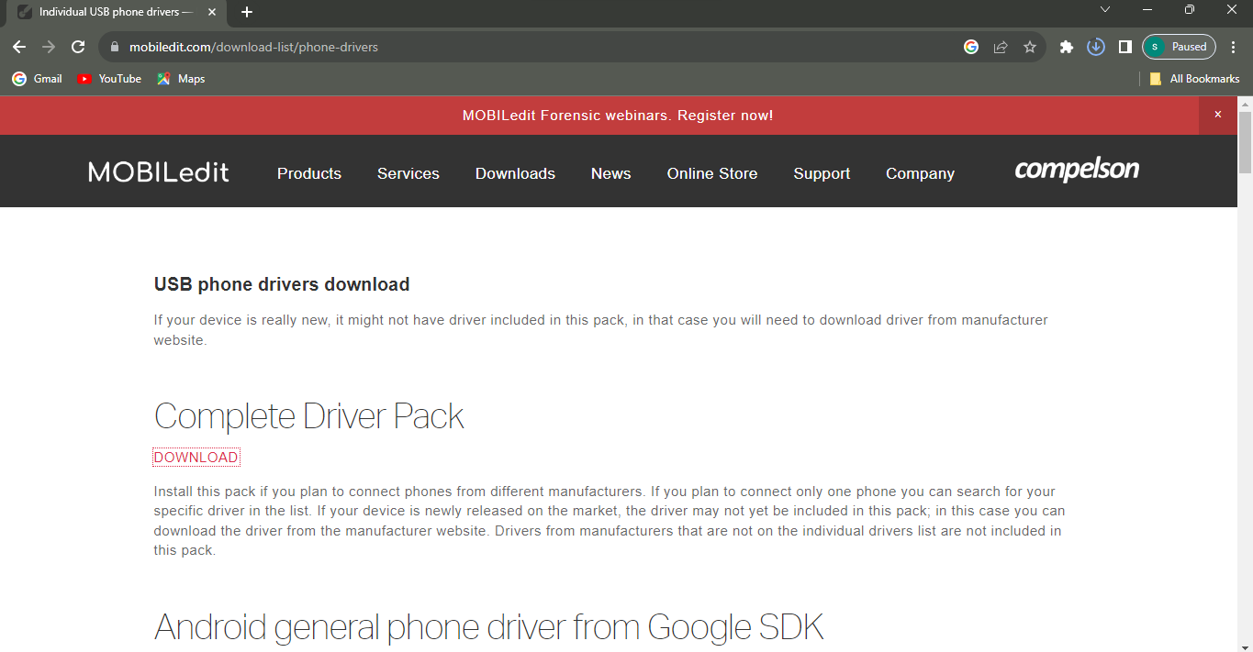

**Connect our phone to the MOBILedit**

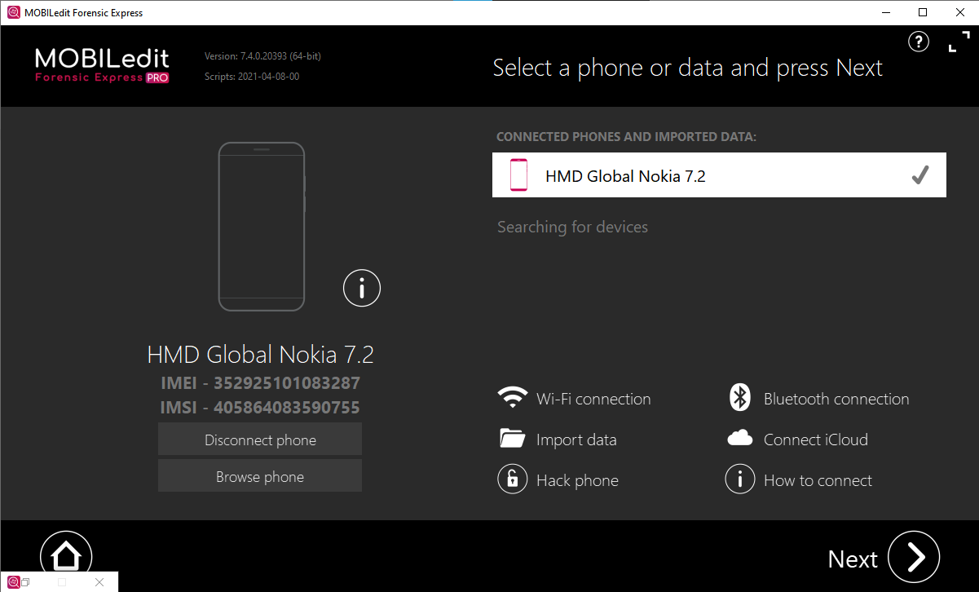

**Connector Installation**

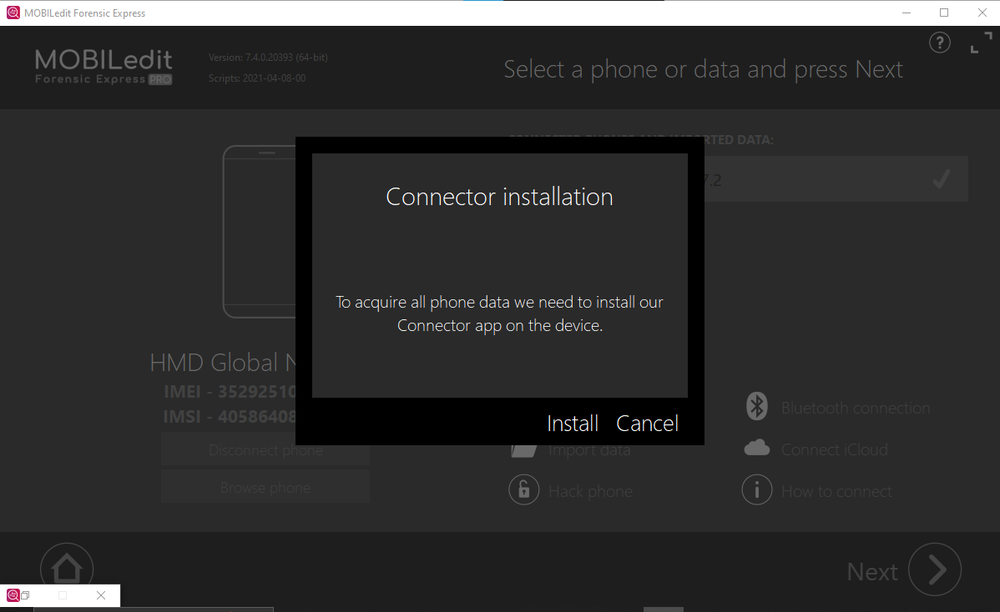

**Phone data peview**

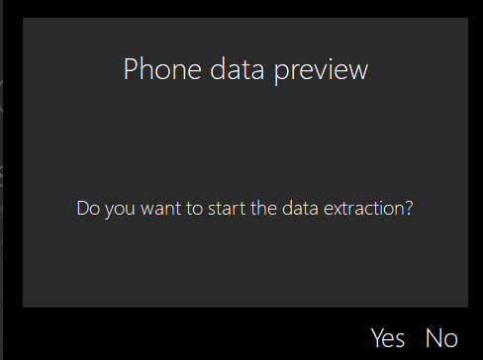

**Data Extraction**

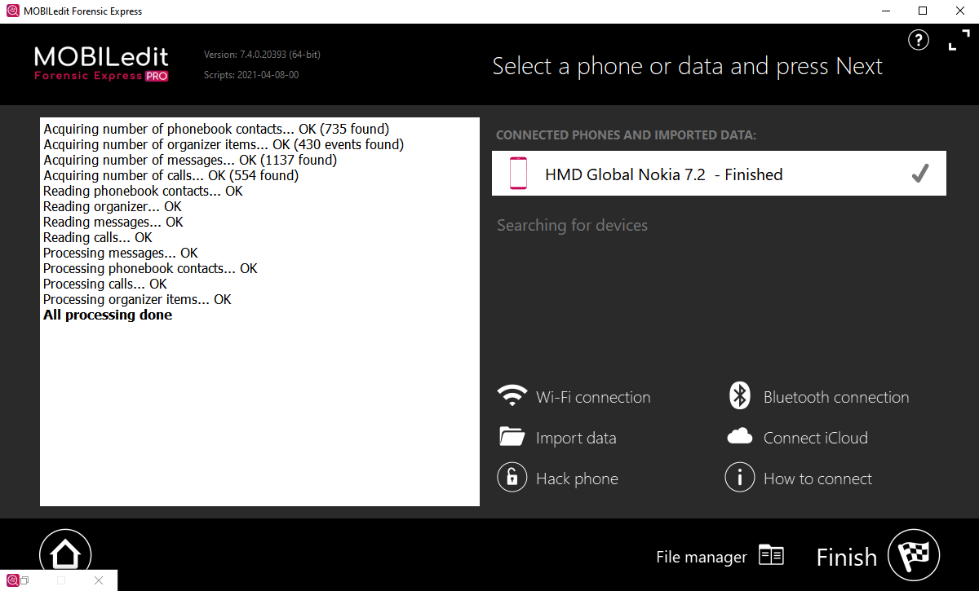

**Choose What to extract**

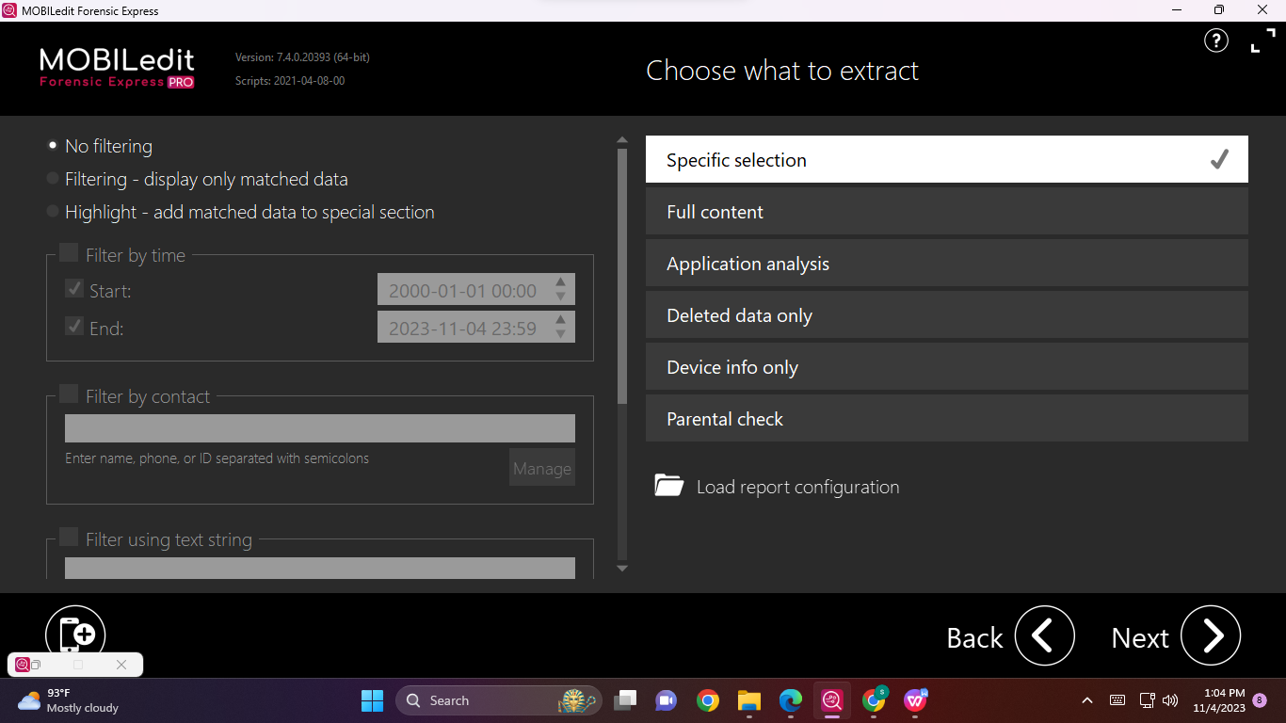

**Phonebook**

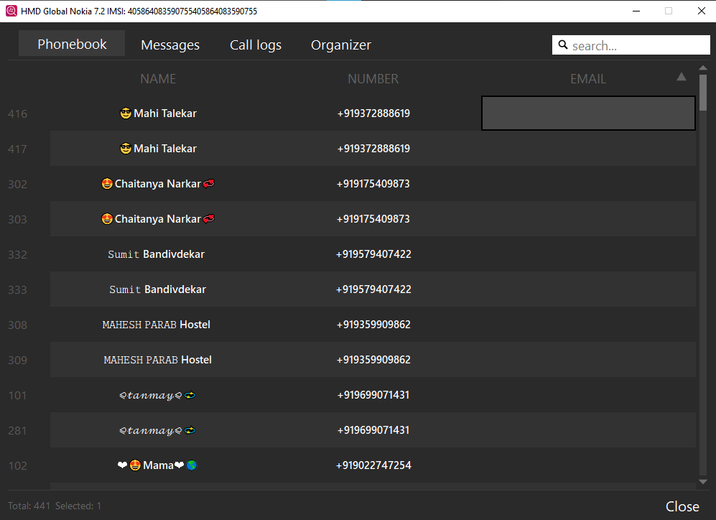

**Message**

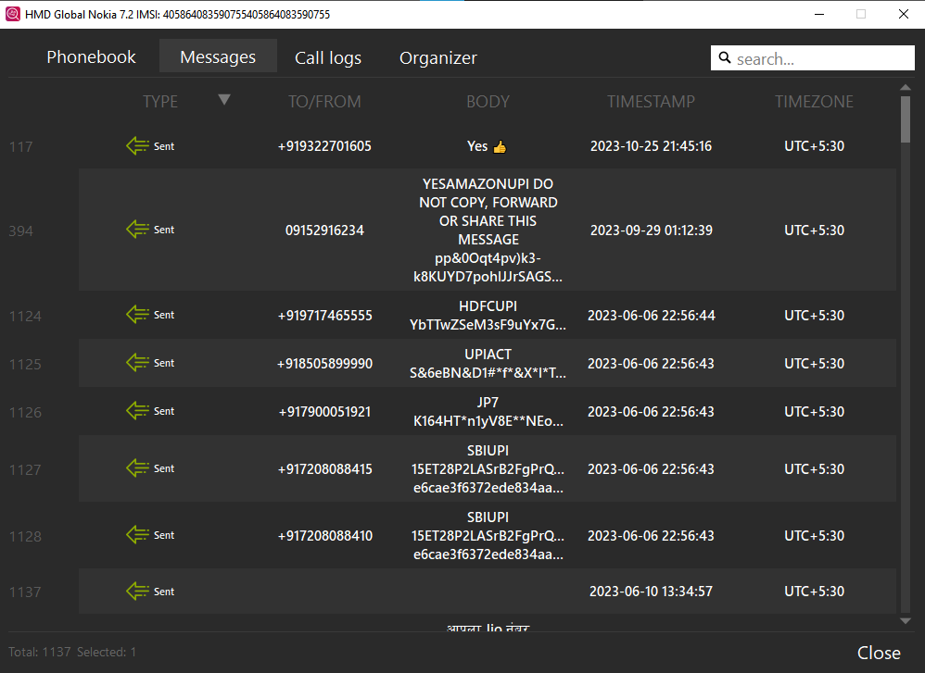

**Call Log**

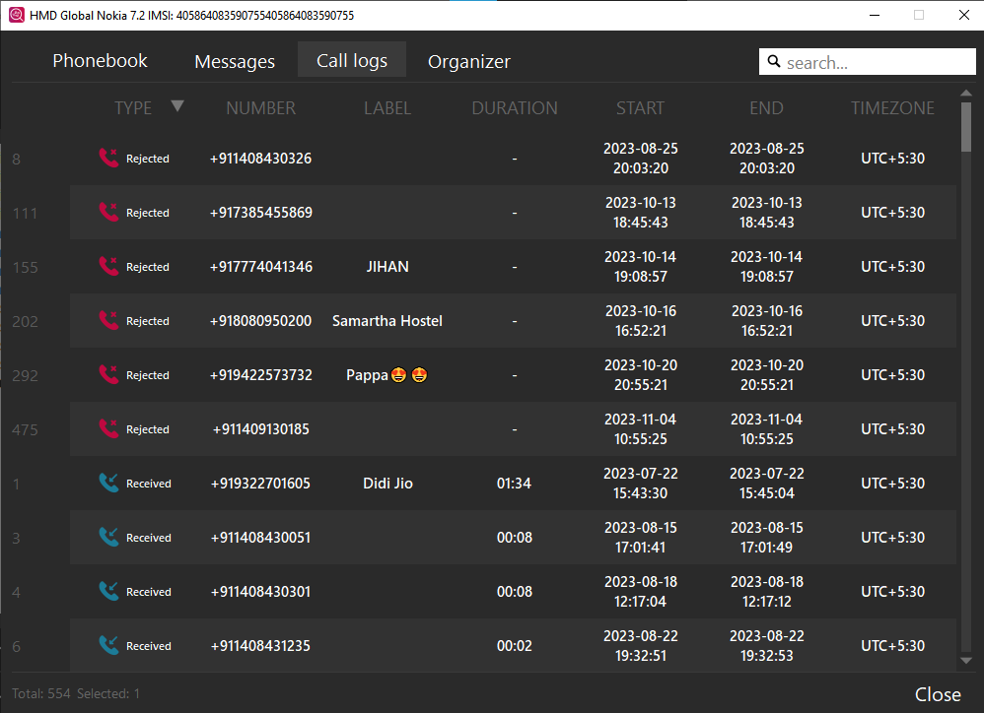

**Configure Your Report**

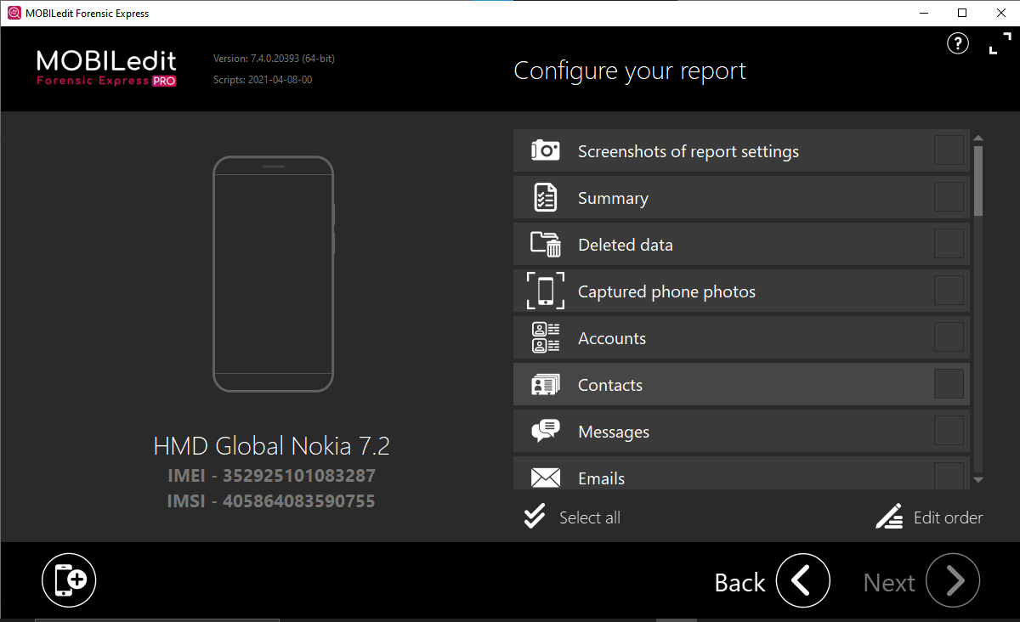

**Select**

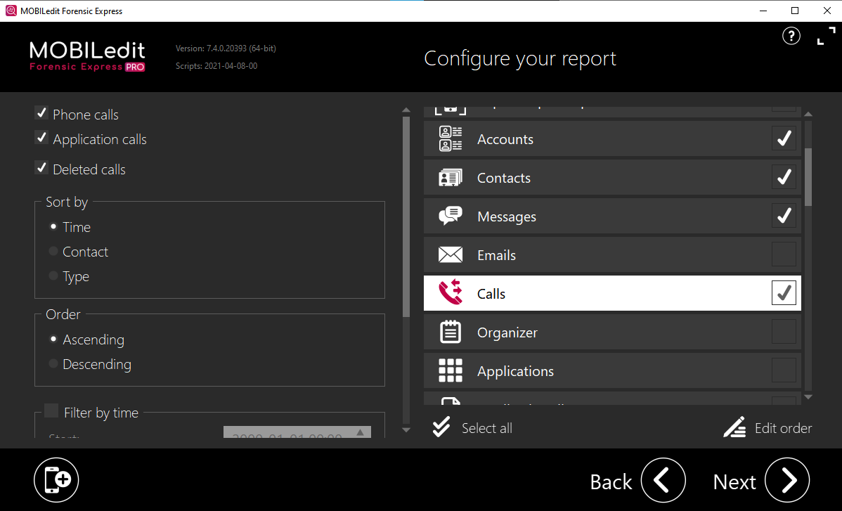

**Choose Report format**

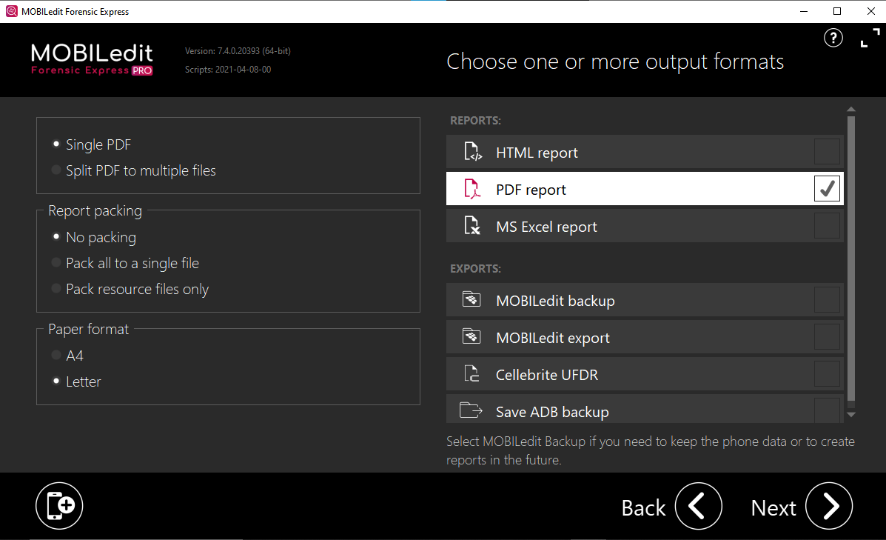

**Export Report**

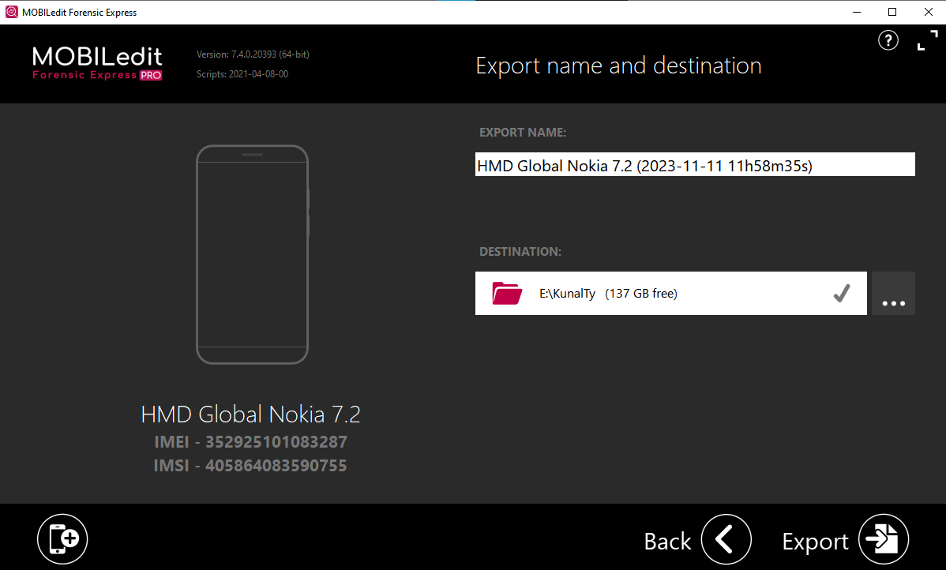

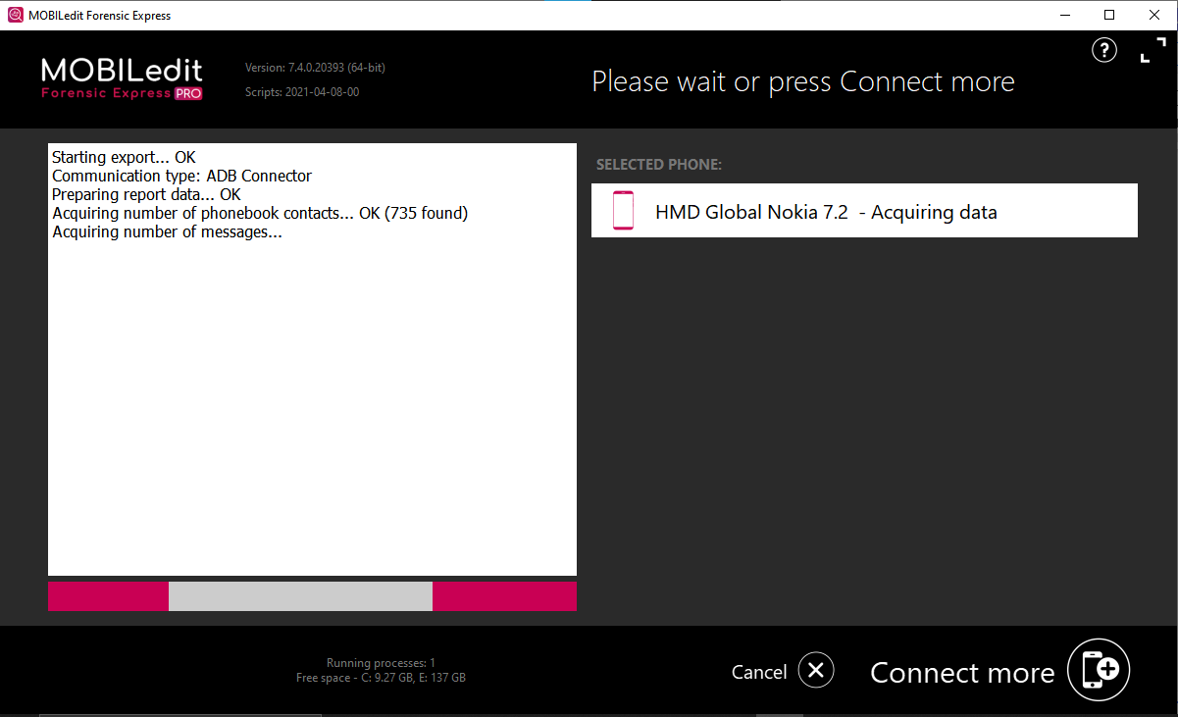

**Start BackUp**

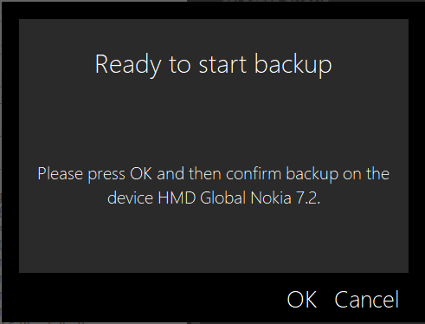

**Creating Reports**

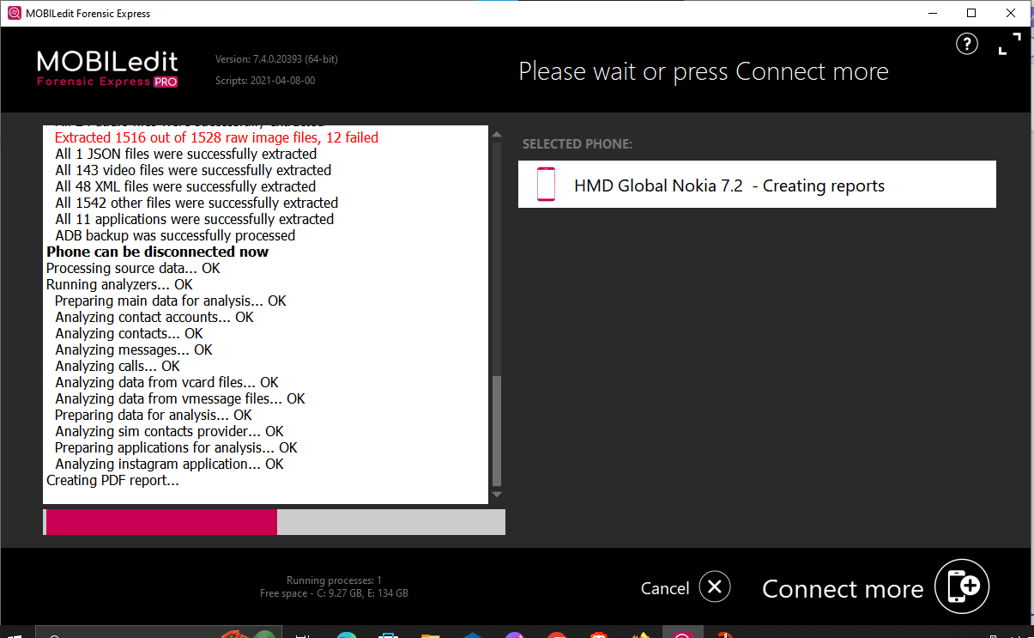

**Extraction complete**

